*[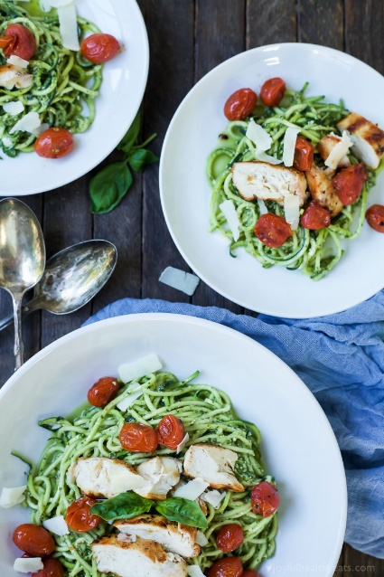](https://www.joyfulhealthyeats.com/wp-content/uploads/2016/03/Pesto-Chicken-Zoodles-with-Burst-Tomatoes-web-4.jpg)***INgredients**

* 3 Zucchini, spiralized
* 2 boneless skinless chicken breasts
* salt & pepper
* 1 1/2 cup cherry tomatoes
* 2 teaspoons olive oil
* 1/2 teaspoon salt
* Basil Pesto

**Instructions**

1. Preheat grill to medium high heat.
2. Season both sides of the chicken with salt and pepper.
3. Place cherry tomatoes in a small bowl along with olive oil and 1/2 teaspoon salt. Toss the tomatoes so they are coated.
4. In the meantime, spiralize the zucchini. Set aside.
5. Pour the pesto over the zucchini noodles. Using salad tongs, mix the pesto in with the zoodles until it is completely combined.
6. Next, place the chicken on the grill and grill each side for 5-7 minutes. (or until there is no more pink)
7. Place cherry tomatoes in a grill basket and grill for 5 minutes, until tomatoes burst.
8. Remove tomatoes and chicken from the grill. Slice the chicken and place both sliced chicken and burst tomatoes into the pesto zoodles bowl. Serve.