Porcupine Sliders

#### **Note** this yeilds 48 servings great to freeze for later, or you can cut it down for a smaller yeild**

#### **INGREDIENTS**

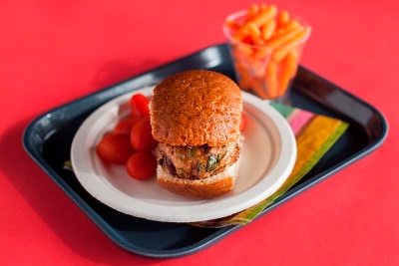1 cup (4 cups cooked) brown rice, long-grain, regular, dry  
2 tbsp + 2 tsp canola oil  
3/4 cup fresh yellow onion, diced  
2 cups fresh celery, diced  
1/4 cup fresh garlic, minced  
8 lbs raw ground turkey, lean  
8 eggs beaten  
2 1/2 cups [Ocean Spray® dried cranberries](https://foodplanner.healthiergeneration.org/products/25-0-lb-25-lb-ocean-spray-craisins-dried-cranberries-original/)  
6 cups fresh baby spinach, chopped  
2 tbsp + 2 tsp Worcestershire sauce  
1 tbsp + 1 tsp salt  
1 tbsp + 1 tsp ground black pepper  
2 tsp ground white pepper  
48 (1 oz each) mini whole-wheat rolls (small dinner roll size)

#### **PREPARATION**

1. Preheat oven to 350 °F.  
2. Combine brown rice and 4 cups of water in a large saucepan and bring to a boil. Turn heat down to low. Cover and cook until water is absorbed, about 30 – 35 minutes. Fluff with a fork. Cover and refrigerate until completely cooled.  
3. Heat canola oil in a large skillet. Add onions, celery and garlic. Cook over medium heat for 5-10 minutes or until tender. Remove from heat. Cover and refrigerate until completely cooled.  
4. In a large mixing bowl, combine turkey, egg, dried cranberries, spinach, Worcestershire sauce, salt, peppers, brown rice and sautéed vegetables. Shape mixture into 48 patties.  
5. Line baking sheets with parchment paper and lightly coat with nonstick cooking spray. Place patties evenly spaced on baking sheets.  
6. Bake uncovered for 20-25 minutes at 350 °F. to an internal temperature of 165 °F. or higher for at least 15 seconds (use a food thermometer to check the internal temperature). Do not overcook. Remove from oven and serve on mini whole-wheat rolls. Serve immediately.  
7. Remove from oven and serve on mini whole-wheat rolls.  
Serve immediately

**Yield: 48 servings**