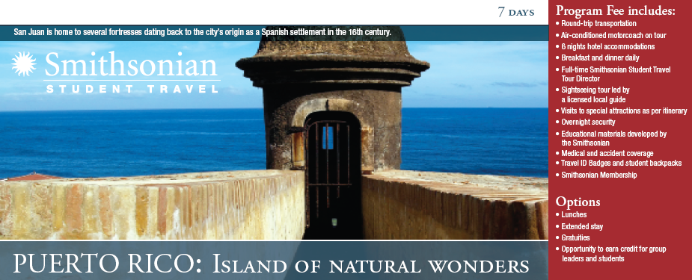

DAY 1: San Juan
Welcome to San Juan • Touch down in San Juan and meet your Smithsonian Student Travel Tour Director, who will accompany you throughout your stay. San
Juan, Puerto Rico’s Old World capital, was founded as a Spanish settlement by Fountain of Youth seeker Juan Ponce de León in the early 16th century. Enjoy free time, depending on your arrival time.

DAY 2: San Juan
Guided sightseeing of El Yunque Rain Forest • This 28,000-acre jungle, complete with bathing spots and spectacular waterfalls, was given national park status by Teddy Roosevelt and is the only tropical rainforest on U.S. soil. Made up of four discrete forest types and offering a number of walking and hiking trails, El Yunque is home to hundreds of species of tropical flora and rare animals like the coquí tree frog (named for its high-pitched croak), the colorful Puerto Rican parrot and the Puerto Rican boa, a serpent that grows to seven feet in length. After viewing a video in the tourist center, you’ll hike through the forest’s trails.

Free time at Luquillo Beach • This afternoon, enjoy free time at Luquillo Beach.
Once a thriving coconut plantation, Luquillo is now one of the island’s best and most popular beaches. Protected by coral reefs, Luquillo’s pristine, calm water provides an excellent spot for swimming.

DAY 3: San Juan to Ponce
Tour-director led sightseeing of Old San Juan • Discover historic Old San Juan.
Steeped in Spanish tradition, the original city was founded in 1521 as a fortress enclave. Start with a stroll along the Paseo de la Princesa, where the Spanish first entered San Juan. An architectural treasure, Old San Juan includes more than 400 beautifully restored buildings exemplifying the 16th- and 17th-century Spanish colonial style. The area is characterized by its wrought-iron balconies, lush greenery and narrow streets paved with adequines (bluish stones used originally as ballast for Spanish ships). See an example of 16th-century Spanish Gothic architecture in the San José Church. Built in 1532, this edifice is one of the oldest churches in the Western Hemisphere, housing the body of Ponce de León (before it was moved to the nearby San Juan Cathedral) for more than three centuries. Pass La Fortaleza. Sitting atop a hill overlooking the ocean, this one-time fortress (built in 1540) is today the Western Hemisphere’s oldest executive mansion in continuous use and the residence of Puerto Rico’s governor. See San Juan Cathedral, the Catholic shrine of Puerto Rico. Originally a thatched wood structure in the 1520s, the church was destroyed by hurricanes only to be more elaborately rebuilt later. See Puerto Rico’s white marble Capitol, which dates from the 1920s. This seat of the commonwealth’s bicameral legislature also offers a magnificent view of sparkling San Juan Bay.

El Morro • Your walking tour culminates with a visit to El Morro, a massive fortress built by the Spaniards between 1540 and 1783. Perched ominously on a rocky promontory 140 feet above the sea, this huge six-level fortress—a Byzantine combination of dungeons, barracks, turrets, towers and tunnels—was built to protect the port. Enjoy a spectacular view of the harbor atop this imposing edifice.

Arrival in Ponce • Continue on to Ponce as you traverse splendid peaks and valleys and pass the Cordillera Central mountains, which provide a stunning backdrop to the drive.

DAY 4: Ponce to La Parguera
Sightseeing of Ponce • Get to know Puerto Rico’s second city. More than 300 years old, Ponce has undergone massive restoration that has recaptured the town’s 19th-century flavor.

Ponce History Museum • Two neoclassical structures are home to the Ponce
History Museum’s collection of cultural artifacts of the Taíno Indians. Develop an understanding of the attributes—development, leadership and quality of life—that give Ponce’s citizens the right to proudly call their town “the Pearl of the South.”

El Vigía Hill and Castillo Serrallés • Marvel at the marriage of mountain and sea from atop Ponce’s 300-foot El Vigía Hill, the area’s tallest geographical feature. The hill features the 100-foot La Cruz del Vigía (Virgin’s Cross), whose observation tower offers breathtaking views of the natural beauty of Ponce. You will also see the nearby Castillo Serrallés (Serralles Castle). A beautiful example of Spanish revival architecture, the castle was once home to the Serralles family, one of the most powerful rum-producing families.

Transfer to La Parguera • Continue to La Parguera.

Phosphorescent Bay • Miles of mangrove canals stand in sharp contrast to the nearby dry forest. Board your boat and see the “wet” side of the forest. Explore secluded Puerto Rican beaches as you travel to fascinating Phosphorescent Bay in the fishing village of La Parguera. While the bay is prime scuba-diving territory, the main attraction is the water itself. On moonless nights, the bay glows when its microscopic marine plankton, disturbed by movement, light up brilliantly!

DAY 5: La Parguera
Snorkeling excursion • The clear waters of the Caribbean are perfect for viewing marine life up close. You’ll have a chance to do just that on today’s half-day snorkeling expedition. You will also see a coral reef, as the waters of La Parguera are known for this type of reef.

Tibes Indian Ceremonial Center • Visit the Tribes Indian Ceremonial Center, the oldest cemetery in the Caribbean and a rich repository of ancient Igneri and pre-
Taíno Indian ruins, dating from A.D. 300 to A.D. 700. The site features ancient ball
courts or “bateyes” and dance grounds where solar readings were once taken. Tour
a re-created Taíno village and a museum documenting the fascinating history of
these native inhabitants.

Return to San Juan • Transfer back to the capital of Puerto Rico.

DAY 6: Camuy to Arecibo to San Juan
Camuy Caverns • Explore the massive cave system known as Camuy Caverns.
The adventure begins as your trolley descends into a sinkhole lined with dense tropical vegetation. Continue over bridges and ramps on foot until you are met with the spectacular sight of the 170-foot-high Cueva Clara and contrast it with the 400-foot-deep Tres Pueblos Sinkhole. You will even have the opportunity to take the 205 steps down to the Spiral Sinkhole!

Arecibo Observatory • This astronomical observatory (functioning as the National
Astronomy and Ionosphere Center) boasts one of the world’s most powerful radar radio telescopes. It is also home to the largest single-unit radio telescope (with a main collecting dish that is over 1,000 feet in diameter), which is used to collect information on radio astronomy, aerononomy and radar observations. The Arecibo telescope has helped scientists make many important discoveries, including the correct rotation of Mercury and the first extra-solar planets ever found.

DAY 7: Departure
Flight home • Your tour director assists with your departure from the San Juan
airport.

Itinerary subject to change. For complete financial and registration details, please refer to the Booking Conditions.

