Name __________________________________ Chemistry
Chapter 8.3 Types of Reactions Worksheet

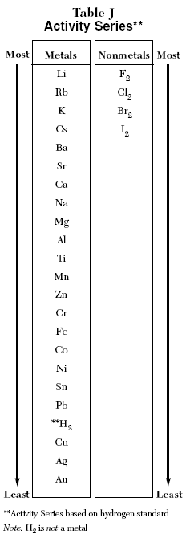
Single Replacement Reactions

Here’s How it works:

Metals: A metal will react with the cation of another metal in solution as long as the metal it is listed above the ion on the activity series

For Example:
Copper in a solution of silver nitrate

It will not work if a metal is listed below the metal cation that is in solution.

For Example:
Aluminum in sodium nitrate

Nonmetals: For Nonmetals: The same trend is seen

For Example:
Chlorine gas bubbled through a solution of aluminum bromide

For Example:
Iodine crystals placed in Sodium Bromide

Metals in Acid: What if a metal is placed in an acid solution?

For Example:

Solid Copper placed in hydrochloric acid Calcium placed in hydrochloric acid

Directions: Use Table J in your Reference Tables to determine if the following reactions will work. Write yes or no according to your table. Also, complete the equations when necessary and balance each equation.

For Example:

___Cr + ___Pb(NO₃)₂ → ________ + ________ ___

Equations Will it work?

1. ___Mg + ___HCl → ___ H₂ + ___MgCl₂ ____

2. ___Zn + ___Al(NO₃)₃ → ______ + ________ ____

3. ___Mg + ___TiCl₄ → ___Ti + ___MgCl₂ ____

4. ___Na + ___CaCl₂ → ______ + ________ ____

5. ___Zn + ___HCl → ___H₂ + ________ ____

6. ___Pb + ___AgNO₃ → ___Ag + ___Pb(NO₃)₂ ____

7. ___Al + ___FeO → ___Fe + ____Al₂O₃ ____

8. ___Pb + ___ZnC₂H₃O₂ → _____ + ________ ____

9. ___Cl₂ + ___AlBr₃ → ___Br₂ + ___AlCl₃ ____

10. ___I₂ + ___NaBr → ___Br₂ + ___NaI ____

11. ___Mg + ___HNO₃ → ___H₂ + ___Mg(NO₃)₂ ____

