Name ________________________________ Regents Chemistry
Chapter 1 HW Assignment

Conversions and Practice with the Dimensional Analysis
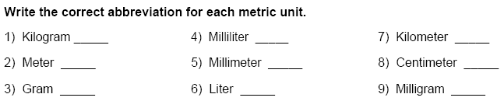

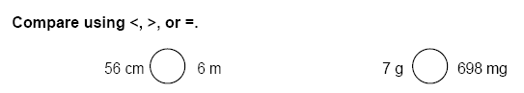

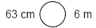

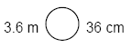
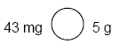
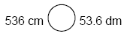

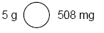

Make the following conversions using the parentheses method of dimensional analysis. Show all work in the spaces provided.

1) 2000 mg = _______ g 4) 5.6 kg = _____ g

2) 104 km = _______ m 5) 8 mm = _____ cm

3) 480 cm = _____ m 6) 5 L = _______ mL

7) 198 g = _______ kg 10) 5.6 m = _____ cm

8) 75 mL = _____ L 11) 16 cm = _______ mm

9) 50 cm = _____ m 12) 2500 m = _______ km

