Name _________________________________ Chemistry

Online Molarity Interactive Lesson

Directions: Go to the website http://genchem.chem.wisc.edu/sstutorial/Text11/molarity/molarityIndex.htm

- Read through the Fish per liter section and answer the questions.
- Read through the moles per liter sections and answer the questions.

- Now click on the Molarity problems section and complete the problems. Use the space provided below for each question and SHOW ALL WORk INCLUDING THE ORIGINAL EQUATION AND SUBSTITUTION WITH UNITS. Check you answers along the way to see you are doing.

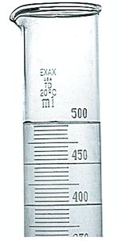
Problem 1: How many moles of NaOH are there in 500 mL of a 2.0 M solution?

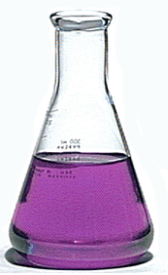
Problem 2: What is the concentration of an aqueous solution that contains 0.0250 moles of potassium permanganate, KMnO4, in a total volume of 250 mL?

Problem 3: How many liters of a 0.10 M solution of ferric chloride would you need to have 1.0 moles?
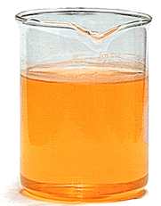

Problem 4: How many grams of K2CrO4 need to be dissolved in enough water to make 1.0 liters of a solution that has a concentration of 0.100 M? (The gram formula weight of K2CrO4 is 194.2 grams.)

