Name ______________________________
AP Chapter 8 Bonding

In this activity we will learn how to draw Lewis structures, calculate formal charge and examine resonance. We will also observe the Octet rule and exceptions to this rule.

AP Chem. Lewis Dot Structure Worksheet

Write Lewis Dot Structures and calculate the formal charges for the following compounds:

1. SO₂ 18. H₂O₂

- CO₃⁻² 19. C₂H₆

- NH₃ 20. CH₃OH

- CH₄ 21. C₂H₄

- H₂ 22. C₄H₁₀

- HF 23. C₂H₅OH

- H₂O 24. ClO⁻

- N₂ 25. H₂S₂

- HCl 26. HNO₃

- H₂S 27. H₂SO₄

- PF₃ 28. CH₃NO₂

- CH₃COOH 29. C₂H₂

- NH₄⁺ 30. ClO₂⁻

- NO₂⁻ 31. PO₄⁻³

- SO₄⁻² 32. CO

- NO₂⁺ 33. CO₂

- OH⁻

Formal Charge

- Formal charges are used when there is more than one possible Lewis structure for a molecule.

- The Formal charge of an atom equals the number of valence electrons in the isolated atom, minus the number of electrons assigned to the atom in the Lewis Structure

- Most stable lewis structure is one where all charges equal zero or the negative charge resides on the most electronegative element.

- Rules:

  - Valence e- for that atom minus left over electrons around atom and ½ e- in the bond
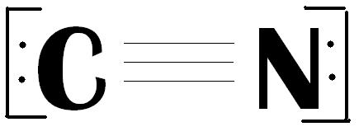
For example:

Valence e-
- e- assigned
Formal Charge

Example #2; Use the same process as above.
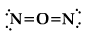
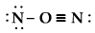
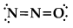

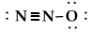
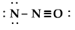

Lewis Structure Worksheet

Lewis Structure Worksheet

Lewis Structure Worksheet

Lewis Structure Worksheet

