Name ____________________________________ Physics
Intro to Momentum Website Activity

Directions: Go the Mr. O’Leary’s Physics Webpage and scroll down to Chapter 6 Momentum and Impulse. Click on the link Conservation of Momentum Tutorial by The Physics Classroom [click] and read through the lesson on Momentum. At the bottom and the next webpage are the questions on this worksheet. Please your answers to the questions on this worksheet. SHOW ALL YOUR WORK.

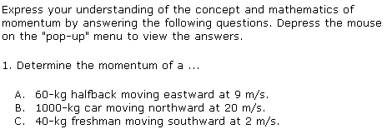

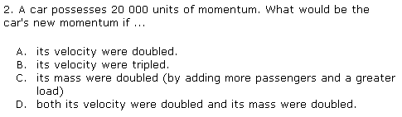

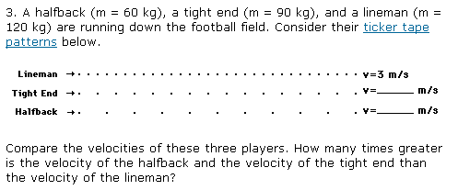

4. Which one of the following has the greatest:
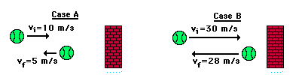

Velocity change? ________________________________________

Acceleration? ___________________________________________

Change in momentum? ___________________________________

5. Which one of the following has the greatest?

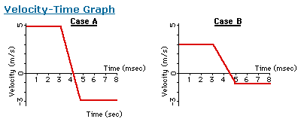

Velocity change? ________________________________________

Acceleration? ___________________________________________

Change in momentum? ___________________________________

I

