Name _____________________________________ Regents Physics

The Work of a Workout
Goals: To determine the amount of work involved in running up a flight of stairs
To determine your power output

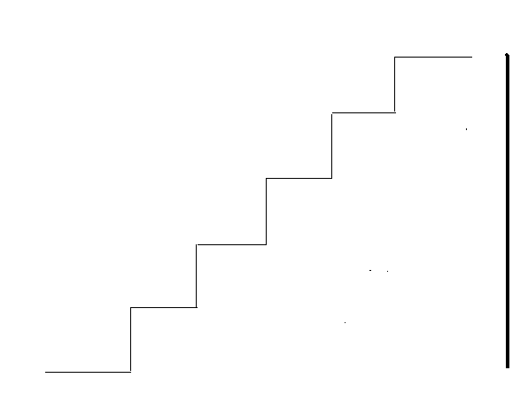
Prelab: Does it require the same amount of work walking up the stairs vs. climbing a rope to get to the same height?

Mass = 75 kg

8.5 m
3.3 m Rope

23 °

Calculate the work against gravity Calculate the work against gravity
Climbing the stairs climbing the rope

Lab Procedure:

1. Measure the height of two flights of stairs
2. Run up the two flights of stairs as you are timed by your partner
3. Perform three trials and record your values in the table below

Trial | Height of Stairs | Force | Time | Work | Power
1 slow speed

2 medium speed

3 fast speed

4. Calculate the force due to gravity on your body and place this value in the table.

5. Calculate the work done against gravity and show your work below

6. Calculate your power rating for each trial and show your work below

Trial #1

Trial #2

Trial #3

Postlab Questions:

1. They say that the same amount of work is done walking down a flight of stars as is done walking up a flight of stairs. Why is this true?

1 b.) Why is it easier then to walk down the stairs than up the stairs? ___________________________

__________________________________________________________________________________

2. Why is direction important? In other words, why is work only done when the force is in the same direction as the movement? For example, if you hold a book and walk across the floor, work is not being done on the book. Why?

__________________________________________________________________________________

__________________________________________________________________________________

4. How is power related to work? _______________________________________________________

5. What happened to the power output when you walked up the stairs at a faster pace? Why? ______

6. We could have calculated the work done by using different measurements. Draw a picture below and describe what other measurements we could have used to get accurate results for the amount of work required to move up the stairs. Hint..think prelab..

