Name __________________________________ AP Chemistry

Directions: This activity is a race between pairs of students to write the correctly name or write chemical formulas for the following compounds.

Rules:
There are (4) pages and you must correctly complete a sheet before moving onto the next sheet
First team to complete all (4) sheets wins!

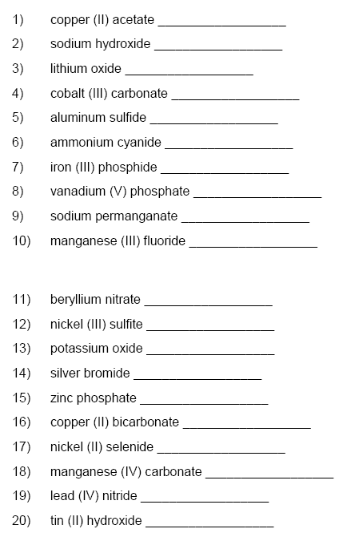

Page 2

Directions: Write the name of the following compounds:

21) KMnO₄ _____________________________________________

22) MgSO₄ _____________________________________________

23) CaSO₃ _____________________________________________

24) H₂O₂ _____________________________________________

25) K₂CrO₄ ____________________________________________

26) Sb(HSO₃)₅ _____________________________________________

27) Sr(ClO)₂ _____________________________________________

28) Fe(NO₃)₃ _____________________________________________

29) NiO _____________________________________________

30) NaCl _____________________________________________

31) Rb₂Cr₂O₇ _____________________________________________

32) NaHCO₃ _____________________________________________

33) Cu₃(PO₄)₂ _____________________________________________

Page 3

Directions: Name the following acids
34) H₂SO₄ _______________________________
35) H₂SO₃ _______________________________
36) HCN _______________________________
37) H₂S _______________________________
38) H₃PO₄ _______________________________

Directions: Write the formulas for the following acids.
39) chloric acid _______________________________
40) perchloric acid _______________________________
41) hydrobromic acid _______________________________
42) hydroiodic acid _______________________________
43) carbonic acid _______________________________

Page 4 – Home Stretch!

Write the formulas for the following compounds

44) antimony tribromide __________________________________

45) hexaboron silicide __________________________________

46) chlorine dioxide __________________________________

47) hydrogen iodide __________________________________

48) iodine pentafluoride __________________________________

49) dinitrogen trioxide __________________________________

Write the names for the following covalent compounds:

50) P₄S₅ __________________________________

51) O₂ __________________________________

52) SeF₆ __________________________________

53) Si₂Br₆ __________________________________

54) SCl₄ __________________________________

Write the formulas for the following bases

55. Magnesium hydroxide ___________________________________

56) Potassium hydroxide ___________________________________

57) Rubidium hydroxide ___________________________________

